Edenham Parish Council - Community Bank Account
Income and expenditure from April 2025 to October 2025

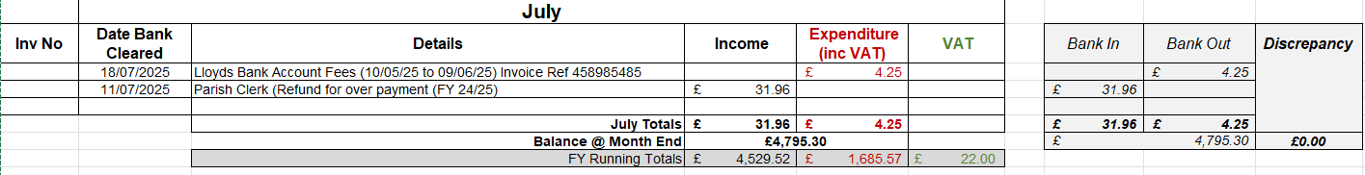

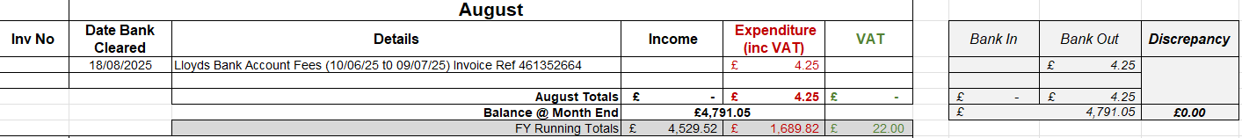

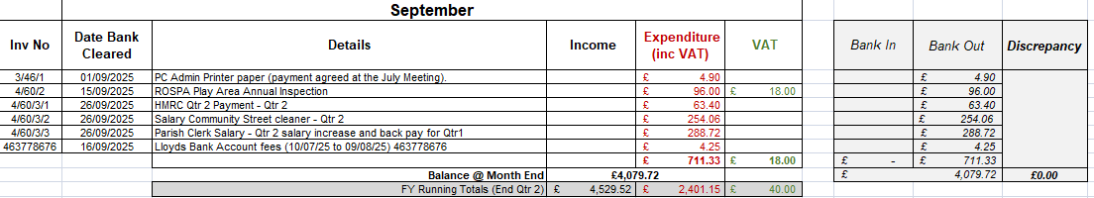

Edenham Parish Council - Interest for Business Bank Account
