Edenham Parish Council - Community Bank Account
Income and expenditure from April 2025 to January 2026

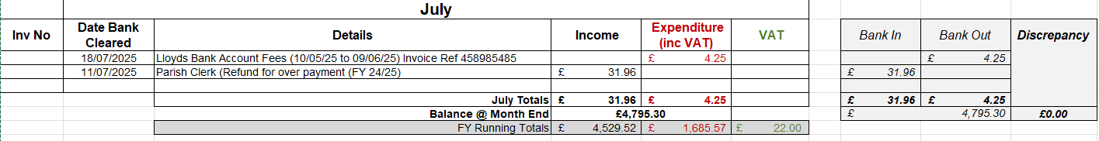
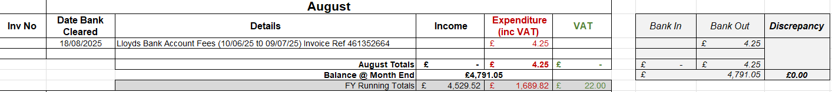

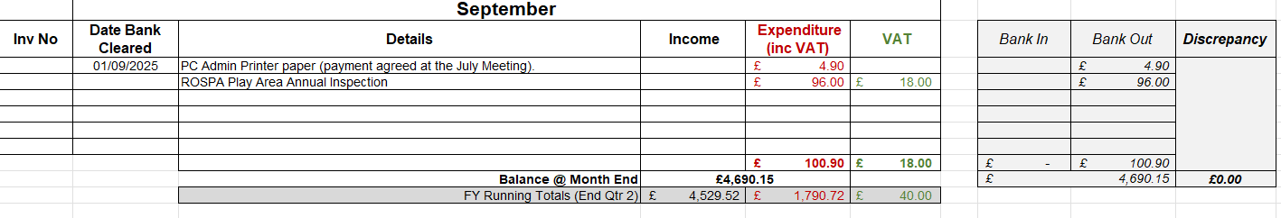
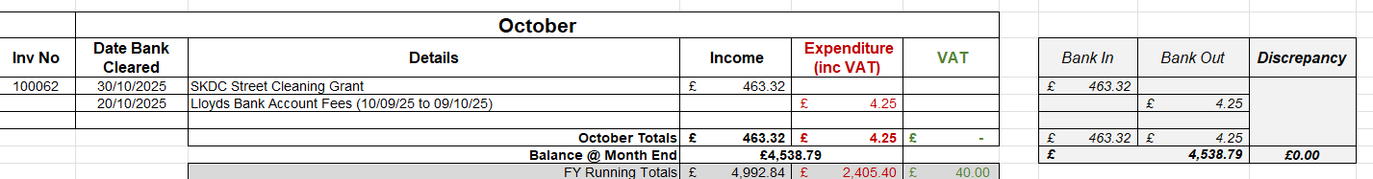
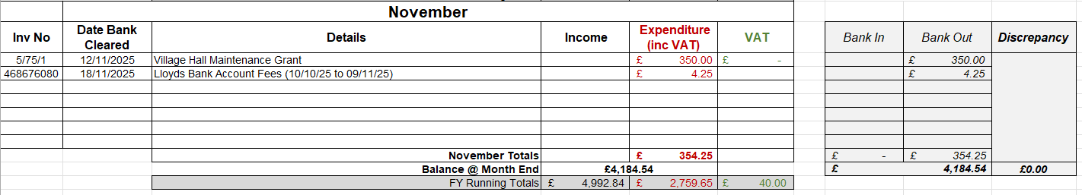
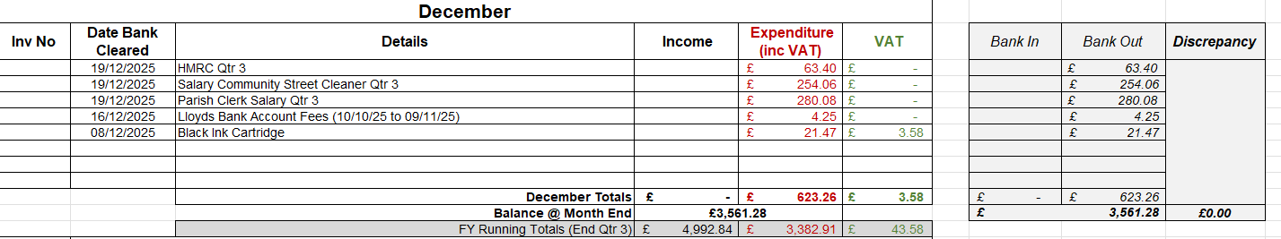

Edenham Parish Council - Interest for Business Bank Account

